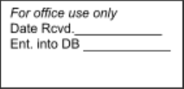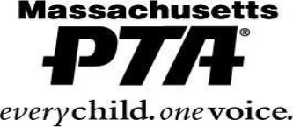

**OFFICERS and CHAIRPERSONS**

Please complete this form in its entirety especially if you have elected any new officers or chairpersons for the 2025-2026 school year. **However, if your officers or chairpersons are remaining the same for the 2025-2026 school year, the form still needs to be filled out since some of the pertinent information (i.e., address, telephone number, email address) may have changed**. **Emails are a must since this is our way of communicating with all of you**. As stated in your bylaws, forms must be returned no later than June 30th, **unless you have a fall election then October 31st.** You may respond via email to [membership@masspta.org](mailto:membership@masspta.org), mail your form to Massachusetts PTA Attn. Karen DeRoche Massachusetts Parent-Teacher Association PO Box 44, Rehoboth, MA 02769 , or you can enter your officers into memberhub. (If you do that, please send us an email confirming it was done)

**Reminder Massachusetts PTA does not share any of this information with 3rd parties.**

**2025-2026**

PTA Name (As stated on your bylaws):

PTA National ID # (8-digit number):

**President** Name:

Address: City: Zip:

**Vice President** Name:

Address: City: Zip:

**Secretary** Name:

Address: City: Zip:

**Treasurer** Name:

Address: City:

Phone:

E-mail:

Phone:

E-mail:

Phone:

E-mail:

Phone:

E-mail:

Zip:

**State Liaison (person other than president)** Name:

Address: City: Zip:

**Membership Chair** Name:

Address:

**Revised: April 2023**

Phone:

E-mail:

Phone:

City: Zip:

**Social Media Coordinator** Name:

Address: City:

E-mail:

Phone:

E-mail:

Zip:

**Health, Safety and Wellness Chair** Name:

Address: City: Zip:

**Advocacy/Legislative Chair** Name:

Address: City: Zip:

Phone:

E-mail:

Phone:

E-mail:

**SCHOOL INFORMATION**

If your PTA Unit includes more than one school, please list all schools.

Type of School(s) (Check all that apply):

❑ Pre-School Elementary ❑ Middle ❑ Junior High ❑ Senior High ❑Jr./Sr.

High ❑ Other ______________

School: Address: City, Zip:

Principal Email

School: Address: City, Zip:

Principal Email

School: Address: City, Zip:

Principal Email

School: Address: City, Zip:

Principal Email

**Revised: April 2023**