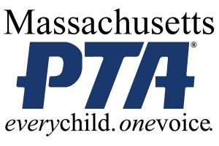

*MEDIA ADVISORY*
[Name of PTA] to Recognize Students for their Outstanding Works of Art in
2015-16 National PTA Reflections Program

Event to feature performances and exhibit of student artwork

WHAT:
On [Date], [Name of PTA] will host an awards ceremony at [Location] to honor students for their imagination, creativity and interpretation of the theme “Let Your Imagination Fly” in the [School Year] National PTA Reflections program. During the event, [list key speakers, including PTA leaders, school and district leaders, and community leaders] will discuss the significance of the arts and the benefits of arts education. The event also will feature music and dance performances by student honorees as well as an exhibit of student artwork.

The National PTA Reflections program encourages students of all ages and abilities to explore and be involved in the arts in an educational way. Through the program, National PTA, [Name of PTA] and PTAs across the country urge students in preschool through grade 12 to create and submit original works of art in the medium of their choice— dance choreography, film production, literature, music composition, photography and visual arts — reflecting on a specific theme. There also is a special artist division option for students with disabilities to ensure that all students have the opportunity to participate in the program. Students are recognized each year for their artistic ingenuity to bring the theme to life in a way that is personal and meaningful.

Founded in 1969, the National PTA Reflections engages nearly 300,000 students and their families in arts education activities each year—encouraging students to explore the arts for fun and recognition. For more information about the program, visit PTA.org/Reflections.

WHEN:
[Day and time of Reflections celebration event]

WHERE:
[Name and address for location of event]

WHO:
[List key attendees who will be participating, including PTA leaders, school and district leaders, and community leaders]

CONTACT:
[Name and contact information]

About PTA
PTA® comprises of families, students, teachers, administrators, and business and community leaders devoted to the educational success of children and the promotion of parent involvement in schools. PTA is a registered 501(c)(3) nonprofit association that prides itself on being a powerful voice for all children, a relevant resource for families and communities, and a strong advocate for public education. Membership in PTA is open to anyone who wants to be involved and make a difference for the education, health, and welfare of children and youth.

###

