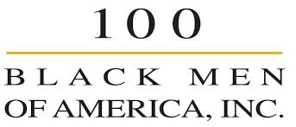
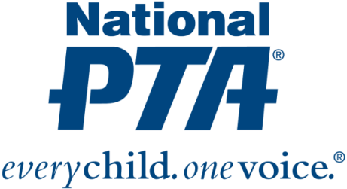

National PTA and 100 Black Men of America Collaborate to Engage More Men in Education

ALEXANDRIA, Va., (May 22, 2015) — National PTA and 100 Black Men of America, Inc. (The 100) have teamed up to educate PTA members, 100 Black Men of America members and the community about the importance of engaging males in key education issues that create an environment where students are motivated to achieve.

100 Black Men of America will join the PTA MORE (Men Organized to Raise Engagement) Alliance, which is dedicated to raising the level of engagement between students and the important men in their lives.

Studies show students perform better when males and females are both involved in their education. Studies also show that men and women think differently and bring different perspectives and skills to the table.

School communities and PTAs also thrive when both men and women participate; yet men remain a largely untapped resource. Including 100 Black Men of America in the PTA MORE Alliance will strengthen the coalition and provide more resources to PTAs.

The PTA MORE Alliance serves as a conduit for greater father and significant male involvement, resulting in positive outcomes and successful relationships for children, parents, schools and communities. The PTA MORE Alliance helps PTA leaders and units:

- Work with schools and communities to provide programs that engage fathers and positive male figures in the educational and social development of children;
- Develop male leaders who work with fathers and male role models to enhance positive involvement with youth; and
- Provide a needed resource for families, communities and schools on fatherhood initiatives and issues.

“We are extremely honored to have 100 Black Men of America, Inc. as a part of our PTA MORE Alliance. It’s a perfect partnership because 100 Black Men of America shares the same goals to educate and empower all children,” said Otha Thornton, president of National PTA.

"We forged a partnership with PTA MORE to leverage our talents and expertise to expand the coverage and impact that both organizations’ work has on increasing opportunities and improving educational outcomes for our youth across the U.S. and beyond. Both organizations share a commitment to education and the significant difference positive male involvement can have on a student," said Brian Pauling, 100 Black men of America, Inc. president and CEO.

About 100 Black Men of America, Inc.
100 Black Men was founded as an organization in New York City in 1963. The national organization, 100 Black Men of America, Inc., began with nine chapters in 1986 as a national alliance of leading African American men of business, industry, public affairs and government with a mission to improve the quality of life for African Americans, particularly African American youth. Today, the organization has over 100 chapters in the United States, England and the Caribbean. Members represent a myriad of professions, including: corporate executives, physicians, attorneys, entrepreneurs, entertainers, elected officials, professional athletes, educators, armed forces and men from numerous other professions. These dedicated men created an international network of mentors focused on creating educational opportunities, promoting economic empowerment, addressing health disparities, and creating positive, nurturing mentoring relationships that extend across a lifetime.

Visit www.100blackmen.org for more information on the programs and initiatives of 100 Black Men of America, Inc. and to connect with The 100’s global network of chapters.

About National PTA

National PTA® comprises millions of families, students, teachers, administrators, and business and community leaders devoted to the educational success of children and the promotion of parent involvement in schools. PTA is a registered 501(c)(3) nonprofit association that prides itself on being a powerful voice for all children, a relevant resource for families and communities, and a strong advocate for public education. Membership in PTA is open to anyone who wants to be involved and make a difference for the education, health, and welfare of children and youth.

Media Contacts:
Heidi May Wilson, National PTA
703-518-1242, hmay@pta.org

Brian Pauling, 100 Black Men of America, Inc.
404-688-5100, bpauling@100bmoa.org

